**BANK FINANCE ANALYSIS**

**INTRODUCTION**

This report provides an in-depth analysis of a financial dataset using DAX functions, hierarchy, relationships, and dynamic dashboards. The primary aim is to extract meaningful insights to inform decision-making. Key metrics, trends, and patterns were evaluated to understand customer behavior, transaction dynamics, and account performance. Additionally, the report explores hierarchical relationships and advanced calculations to enhance the granularity of the analysis.

**DAX Functions and Calculations**

**1.TOTAL TRANSACTION**: Counts all non-blank transaction IDs to compute the total number of transactions.

Total Transactions = COUNT('financial_dataset_extended'[Transaction_ID])

**2. TOTAL TRANSACTION AMOUNT**: Sums up all transaction amounts to evaluate revenue

Total Transaction Amount = SUM('financial_dataset_extended'[Amount])

**3. TOTAL DEBIT AMOUNT:** Calculates total debit transactions by filtering entries labeled "Debit."

Total Debit Amount = CALCULATE(SUM('financial_dataset_extended'[Amount]), 'financial_dataset_extended'[Transaction_Type]= "Debit")

**4. TOTAL CREDIT AMOUNT:** Sums the transaction amounts tagged as "Credit."

Total Credit Amount = CALCULATE(SUM('financial_dataset_extended'[Amount]), 'financial_dataset_extended'[Transaction_Type] = "Credit")

**5. RUNNING BALANCE:** Maintains a progressive total of transactions based on their date.

Running Balance =

CALCULATE(

    SUM('financial_dataset_extended'[Amount]),

    FILTER(

        ALL('financial_dataset_extended'),

        'financial_dataset_extended'[Date] <= EARLIER('financial_dataset_extended'[Date])

    )

)

**6. YTD TRANSACTION AMOUNT:** Summarizes the yearly transaction data.

YTD Transaction Amount =

TOTALYTD(

    SUM('financial_dataset_extended'[Amount]),

    'financial_dataset_extended'[Date]

)

**7. CUSTOMER LIFETIME VALUE:** Computes the average revenue per customer by dividing the total transaction amount by distinct customer accounts.

Customer Lifetime Value =

DIVIDE(

    SUM('financial_dataset_extended'[Amount]),

    DISTINCTCOUNT('financial_dataset_extended'[Account_ID])

)

**8.AGE GROUP:** Groups customers into age ranges: 18–25, 26–40, 41–60, and 61+.

Age Group =

SWITCH(

    TRUE(),

    'financial_dataset_extended'[Customer_Age] <= 25, "18-25",

    'financial_dataset_extended'[Customer_Age] <= 40, "26-40",

    'financial_dataset_extended'[Customer_Age] <= 60, "41-60",

    "61+"

)

**RELATIONSHIPS**

**FINANCIAL_DATASET(DATE) – DATE(DATE)**

**HIERARCHY**

To structure and deepen the analysis, the following hierarchies were established:

**TIME HIERARCHY:**

Year → Month Name → Month Number → Date.

**ACCOUNT BALANCE HIERARCHY:**

Account_ID → Account_Type.

**CUSTOMER HIERARCHY:**

Customer_Age → Customer_Gender.

**MERCHANT HIERARCHY:**

Merchant_Name → Transaction_Type → Transaction_Mode → Card_Type.

**VISUALIZED DASHBOARDS**

Three comprehensive dashboards were developed to provide an intuitive understanding of transaction and customer insights.

**DASHBOARD 1: TRANSACTION AND CUSTOMER ANALYSIS**

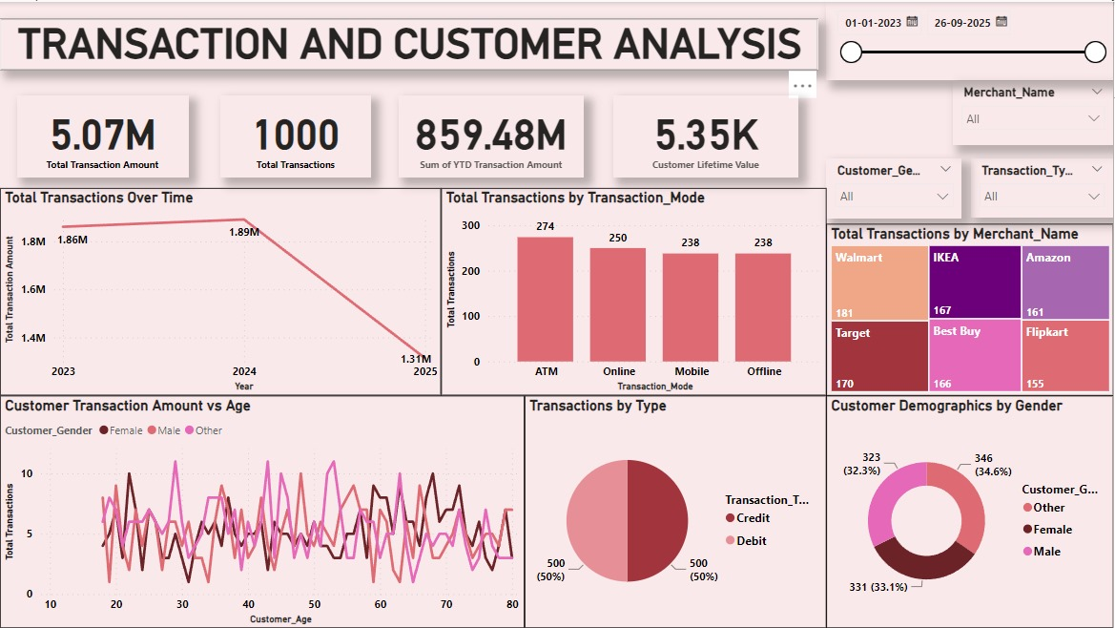

**OVERVIEW:** Tracks customer transactions and behavior.

**KEY METRICS:**

Total Transaction Amount: *5.07M*

Total Transactions: *1000*

YTD Amount: *859.48M*

CLV: *5.35K*

**INSIGHTS:**

***Trends Over Time****:* Transaction volume declined in 2025.

***Transaction Mode****:* Balanced across ATM, Online, Mobile, and Offline.

***Top Merchants****:* Walmart, IKEA, and Amazon dominate.

***Demographics****:* Gender and age significantly impact transactions.

***Type of Transactions****:* Equal split between Credit and Debit.

**DASHBOARD 2: ACCOUNT INSIGHTS**

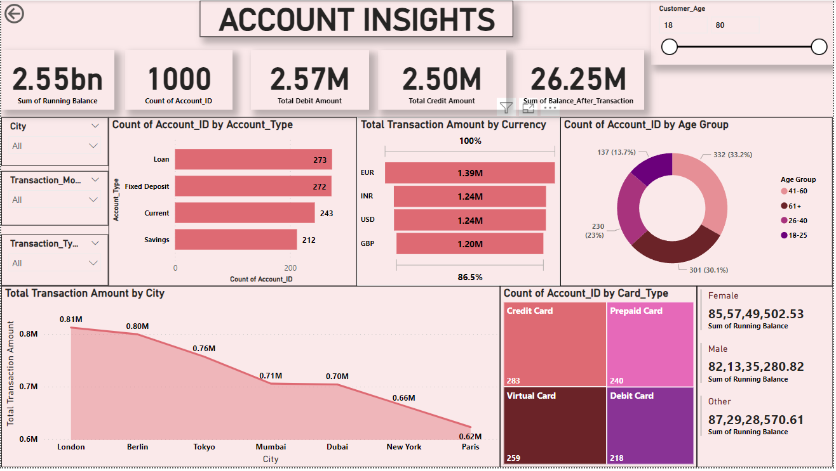

**OVERVIEW:** Focuses on account types, cities, and transaction details.

**KEY METRICS:**

Running Balance: *2.55bn*

Total Credit: *2.50M*

Total Debit: *2.57M*

Account Count: *1000*

**INSIGHTS:**

Loan accounts have the highest transaction volume.

London sees the highest activity; Paris the least.

Currencies (EUR, INR, USD, GBP) contribute equally.

Credit Cards lead account types.

**DASHBOARD 3: TIME ANALYSIS**

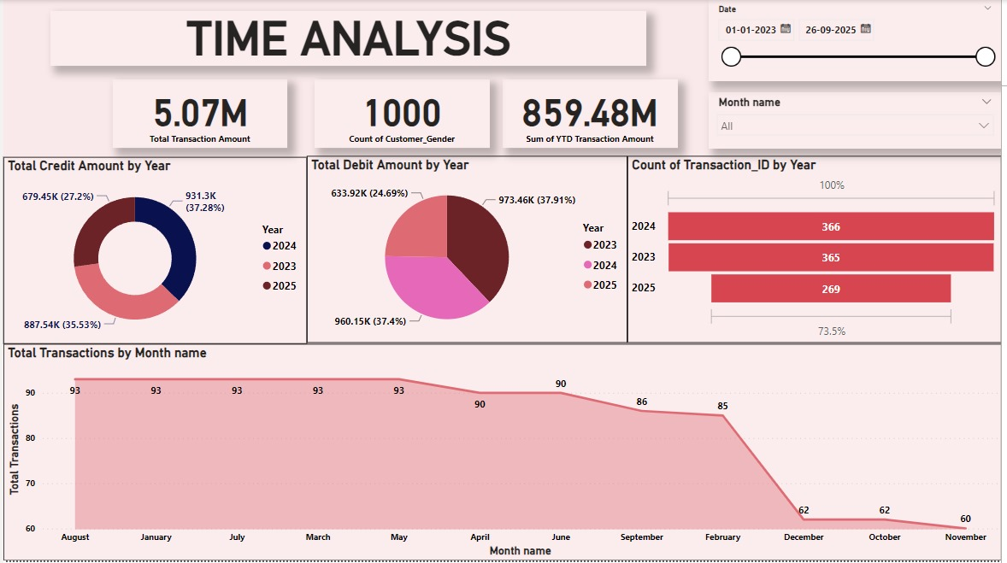

**OVERVIEW:** Analyzes yearly and monthly transaction trends.

**KEY METRICS:**

Total Transaction Amount: *5.07M*

YTD Amount: *859.48M*

Customer Count: *1000*

**INSIGHTS:**

Transaction activity peaked in 2023–2024 but declined in 2025.

Credit transactions were highest in 2023, while Debit peaked in 2025.

Monthly transactions remained steady but saw a drop in November.

## ****CONCLUSION****

The financial analysis highlights key trends and insights, such as the balanced use of transaction modes, demographic impacts on transaction behavior, and geographic disparities in account activity. The dashboards provide actionable insights for stakeholders, emphasizing areas like customer segmentation, transaction trends, and performance across years. This approach to financial analysis can drive strategic decision-making and operational improvements.